# Front-End Technologies Basics: Common Issues

# Issues in the Terminal

## npm error code ENOENT

**Steps to Reproduce the Issue**

You execute the command npm install in the terminal window, but the needed dependencies are not installed. Instead, you see the following error:

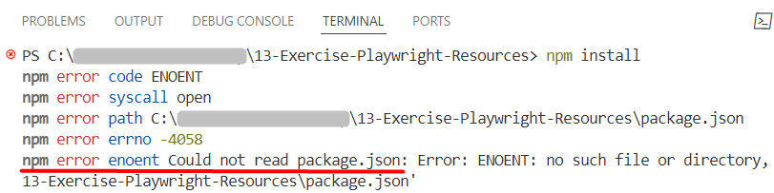

**Probable Reasons**

Your terminal is not open in the folder of the task (where the file **package.json** is).

**Solutions**

**Navigate to** **the folder of the task** you will be working on. This is the folder which contains the package.json file for the application. In the example below, you have two nested folders with the same name. When you first open the terminal, it is in the main folder of the resources, where there is no package.json file. In order to go to the inner folder, you need to go one level down. Type "cd ", press Tab once to select the first subfolder (13-Exercise-Playwright-Resources), and press Enter to navigate to the selected folder:

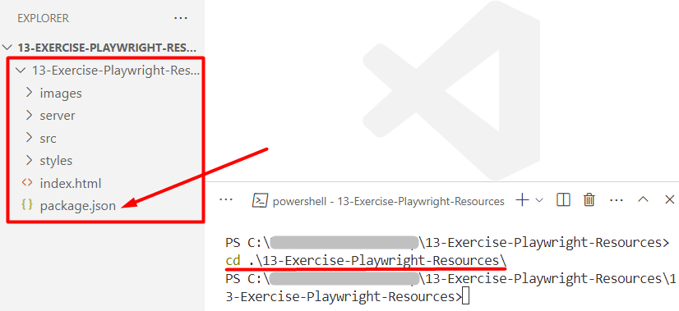

## Missing script: "start" /"server"

**Steps to Reproduce the Issue**

You execut the command npm start and you get this error:

**Probable Reasons**

Your terminal is not open in the folder of the task (where the file **package.json** is).

**Solutions**

**Navigate to** **the folder of the task** you will be working on. This is the folder which contains the package.json file for the application. In the example below, you have several tasks in the provided resources. When you first open the terminal, it is in the main folder of the resources, where there is no package.json file. In order to go to the folder of the first task (01.Bus-Stop), you need to go one level down. Type "cd ", press Tab once to select the first subfolder (01.Bus-Stop), and press Enter to navigate to the selected folder:

## 'http-server' is not recognized

**Steps to Reproduce the Issue**

You execute the command npm start and you get this error:

**Probable Reasons**

You have not installed the needed dependencies.

**Solutions**

In the folder of the task you will be working on, execute the command npm install and then use the command npm start to start the application:  
**IMPORTANT**: Do NOT execute the command npm audit fix --force, as this could prevent the application from running properly in the browser.

# Issues in the Browser

## Page Not Loading

**Steps to Reproduce the Issue**

You type "localhost:3000" in the browser address bar, but you don’t see any web page:

**Probable Reasons**

You have not started the application.

**Solutions**

In the folder of the task, execute the command npm start to start the application:

## ERR_CONNECTION_REFUSED

**Steps to Reproduce the Issue**

As you interact with your application in the browser, you get the following error:

**Probable Reasons**

You have not started the server that is available for you in the resources.

**Solutions**

In a **new terminal window**,navigate to the folder "server" and execute the command node server.js:

